Play Ground Inspection - 25-11-03

The key actions from the inspection are as follows:

As of 25-11-05 the site has had two inspections by BY .
All surface areas have been swept twice
Table tennis Table plus 3 children’s play activities have been cleaned
All equipment has had one safety check by BY.
BY has contacted inspection company / WSC to arrange a meeting with the Inspector to discuss further action. WSC have responded and we are organising a date to meet

Detailed information can be found on P2-3

Summary

MAIN AREAS FOR ACTION: - BY
- BY to purchase padlocks, keys and protective caps
- Repair to Table tennis table – Corneillau contacted to supply protective corners (ref number 25053885.) Cost £11:50 see attached doc. Requires approval for payment?

MAIN AREAS FOR ACTION:: - Requiring Professional Tradesman
- Removal of tree stump ( Stump Grinder required)
Quotes requested
Companies contacted 7th Nov
- J.S.Tree & Garden Services – preparing quote 10th Nov
- JW Tree Surgery & Gardens – awaiting response
- Silverstar Landscaping & Tree Services – awaiting response
- Top Garden Services – awaiting response

MAIN AREAS FOR ACTION: To be discussed with Inspector:
- Trip Hazards
- Surface erosion around benches etc
- Rust to metal frames
- Strimmer damage to wood
- Loose fixings and missing components
- Wear and tear of fixings

- For more detailed information see pages 2-3

Invoices and Estimates
Invoice – New Broom = £17:00 | Estimate- Corneille Table tennis Table Pads = £11:50
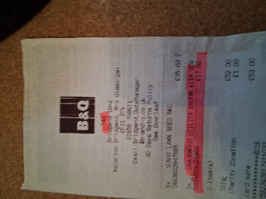 | 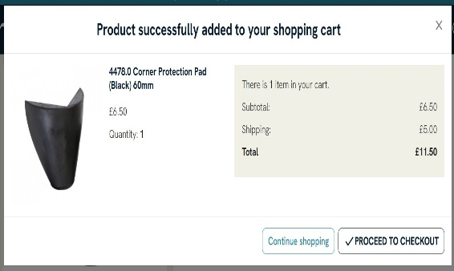
BY to send Bank details once authorised

Green – has been actioned, partially actioned or ongoing
Red - To be actioned during next inspection.
Black- not actioned or awaiting advice from the Inspector

Site General
- Grass mats are silted up and soil is compacted, potentially affecting impact-absorbing properties. ​ Action: Consider HIC testing and replace as needed. ​
- Trip hazards at the edges of the surface. ​ Action: Reinstate surrounding surface levels to remove trip points. ​
- Tree debris on the surfacing. ​ Action: Remove and maintain. ​DONE BUT ONGOING. SITE SWEPT TWICE THIS AUTUMN
- Tree stump remains after removal. ​ Action: Remove stump. Quotations requested ​
- Loose, damaged goal padlock on the fence. ​ Action: Remove. ​

Sign
- Sign needs refixing/missing. ​ Action: Re-site the sign near the entrance gate. ​DONE
- Projecting bolt threads present. ​ Action: Remove excess thread length and deburr DONE or provide cap. ​
- PSPO sign incorrectly sited. ​ Action: Install on or near the gate. ​DONE

Gate - Combination ​
- Surface eroded, exposing foundations. ​ Action: Reinstate surrounding surfaces to cover foundations. ​
- No padlock on the maintenance gate. ​ Action: Provide a padlock to secure the gate.(NO ACTION TO BE UNDERTAKEN BY RECOMMENDATION OF PC) ​

Fence - Bow Top ​
- Item damaged. ​ Action: Monitor for further deterioration and replace as required. ​

Bench
- Area around the bench eroded and slippery. ​ Action: Reinstate eroded area. ​
- Exposed screw. ​ Action: Remove screw. ​TBC ON NEXT INSPECTION
- Evidence of rot in timber. ​ Action: Monitor for deterioration and replace as required. ​
- Projecting screw. ​ Action: Remove excess thread. ​
- Projecting bolt threads present. ​ Action: Remove excess thread length and deburr or provide cap. ​

Picnic Table
- Tree debris on surfacing. ​ Action: Remove and maintain. ​DONE
- Surface eroded and slippery in wet conditions. ​ Action: Reinstate the surface. ​
- Projecting bolt threads present. ​ Action: Remove excess thread length and deburr or provide cap. ​

Litter Bin
- Lid or door not secured. ​ Action: Ensure the lid or door is kept locked. ​TRIANGULAR KEY NEEDED BY TO SOURCE

Table Tennis
- Protective corner cover missing. ​ Action: Replace cover. ​COURNEILLE TO BE CONTACTED
- Corner Protection pads for a Corneillau Campus Outdoor table to be ordered (Ref 510M) Contacted 6/11/25
(ref number 25053885.) Cost £11:50 see above

1 Bay 2 Seat (Flat) Swing ​
- Paintwork damaged, exposing rusting metal. ​ Action: Treat rusting components and repaint. ​
- Paint flaking off metalwork. ​ Action: Rub down and repaint. ​
- Trip hazards at the edges of the surface. ​ Action: Reinstate surrounding surface levels to remove trip points. ​
- Wear to shackles. ​ Action: Monitor and replace when 40% worn. ​CHECKED

Climbing Frame
- Timber has splits/shakes or cracks, potentially affecting stability. ​ Action: Monitor for instability or water ingress.
- Surface corrosion/rust present. ​ Action: Treat the item.
- Weed/vegetation growth on surfacing. ​ Action: Remove growth. ​CHECKED AND WILL DISCUSS WITH SITE INSPECTOR
- Loose fixings. ​ Action: Secure all loose fixings. CHECKED
- Connecting lugs showing wear. ​ Action: Monitor and repair as required. ​CHECKED
- Bolt cap covers missing/damaged. ​ Action: Replace covers. ​
- Paint flaking off metalwork. ​ Action: Rub down and repaint. ​

Crawling Tunnel
- Tree debris on surface. ​ Action: Remove. ​DONE
- Algae or moss on equipment surface. ​ Action: Clean and treat appropriately.
- Gaps between surfacing and edging/joints. ​ Action: Monitor and repair as required. ​
- Missing components. ​ Action: Consider replacing missing components. ​
- Surface lifting at edges, creating trip points. ​ Action: Repair perimeter to remove trip points. ​

Car
- Algae or moss on equipment surface. ​ Action: Clean and treat appropriately. DONE
- Minor surface damage. ​ Action: Monitor and repair as required. ​DONE

Multi Play (Toddler) ​
- Strimmer/machinery damage on posts, potentially accelerating rot. ​ Action: Monitor for deterioration and replace as required. ​

1 Bay 2 Seat (Cradle) Swing ​
- Paint flaking off metalwork. ​ Action: Rub down and repaint. ​
- Tree debris on surface. ​ Action: Remove. ​DONE
- Trip hazards at edges of surface. ​ Action: Reinstate surrounding surface levels to remove trip points. ​

Spring See-Saw
- Bolt cap covers missing/damaged. ​ Action: Replace covers. ​
- Algae or moss on equipment surface. ​ Action: Clean and treat appropriately. DONE
- Equipment loose in foundations. ​ Action: Monitor. ​

Basket Swing - Type 1 ​
- Timber has splits/shakes or cracks, potentially affecting stability. ​ Action: Monitor for instability or water ingress.
- Ropes/nets worn/damaged. ​ Action: Monitor and repair/replace as required. ​
- Wear to shackles. ​ Action: Monitor and replace when 40% worn. ​CHECKED
- Strimmer/machinery damage on posts, potentially accelerating rot. ​ Action: Monitor for deterioration and replace as required. ​
- Sanded wood causing delaminating, potentially leading to rot. ​ Action: Monitor for deterioration.
- Suspension fixings loose. ​ Action: Secure loose fixings. ​ CHECKED AND WILL DISCUSS WITH SITE INSPECTOR

Goal End (AREA TO BE DISCUSSED WITH SITE INSPECTOR)
- Area around item eroded and slippery. ​ Action: Reinstate eroded area. ​
- Tree canopy overhangs equipment, less than 2m clearance. ​ Action: Lift tree canopy to ensure minimum clearance. ​
- Movement in foundations. ​ Action: Monitor for deterioration. ​
- Timber rough/splintered. ​ Action: Remove rough/sharp edges. ​
- Evidence of rot in timber. ​ Action: Monitor for deterioration and replace as required. ​

These findings highlight maintenance needs to ensure safety and functionality of the inspected items. ​

